Abhishek Ojha

Seat No 027

practical no 3

CRUD Operation on MongoDB

**Practical No: 3**

**Aim:** To perform CRUD Operation using MongoDB.

**Software Requirement:**

MongoDB.

**Practical Implementation Steps :**

* **Step 1:-** Open CMD and hit command “Mongo” [To directly run MongoDB from Command Prompt we need to First Set the Environment Variable for MongoDB].
* To set Environment Variable Follow the Steps:
* Open C drive -> Program Files -> MongoDB -> server -> 5.0 -> bin

C:\Program Files\MongoDB\Server\5.0\bin [Copy the Path].

* Start -> Search For “Edit the System Environment Variable” -> Open.
* Add the Copied Path in System Variable and done.

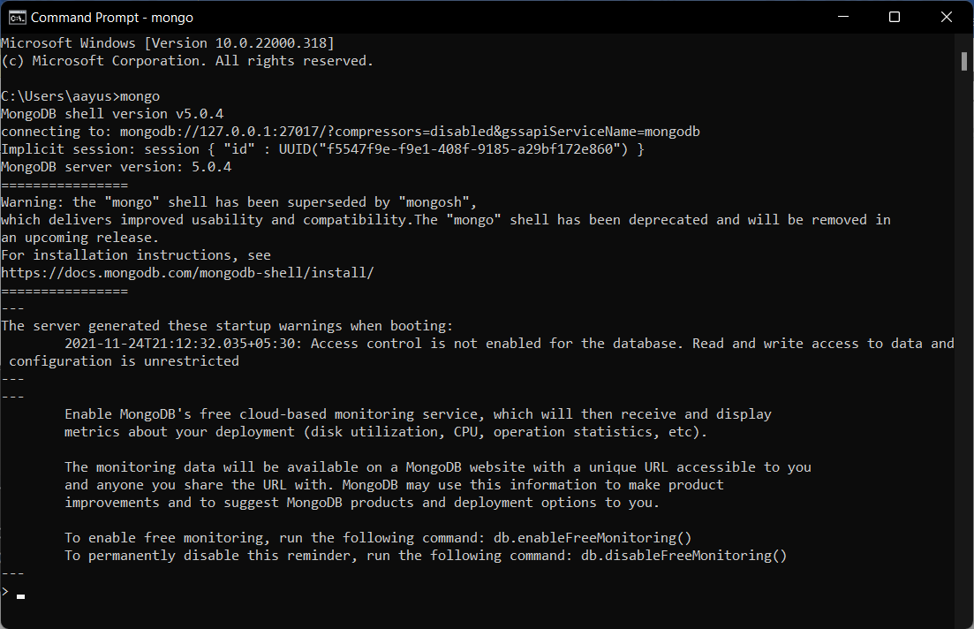

* **Step 2:** Creating and selecting database

**Command :** use aayushman027 [i.e. aayushman027 is Database Name].

**Note:** To list all Database use the command : Show dbs.

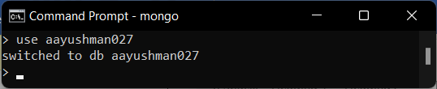

* **Step 3:** Creating Collections and Inserting Values **[C - Create]**

Creating a collection and inserting values can be done together. Here we have or collection name as ‘student ‘.

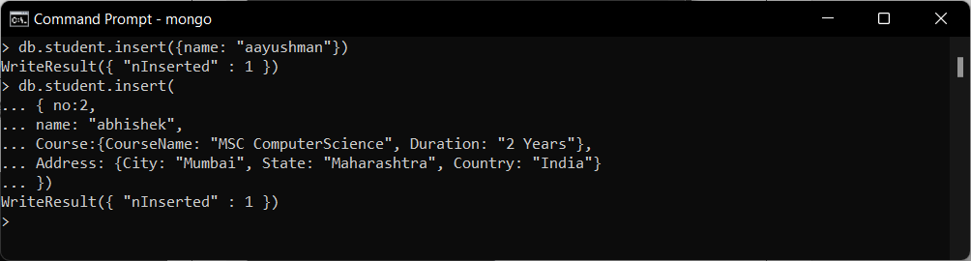

* **Step 4:** Read Data from the Collections **[R - Read]**

To retrieve the inserted document.

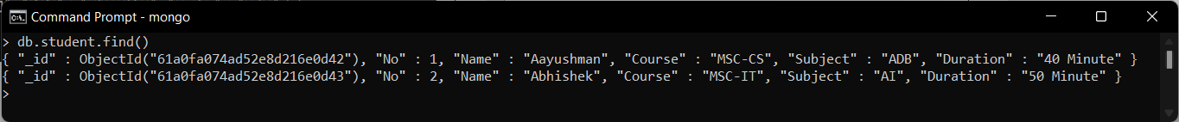

* **Step 5:** Updating a Document in a Collection [**U - Update**].

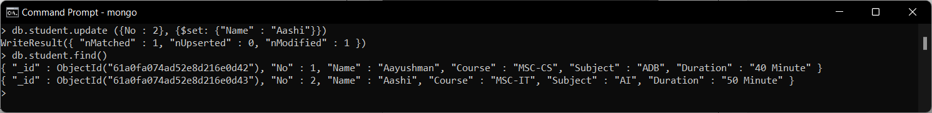

* **Step 6:** Removing an Entry From the Collection[**D- Delete**].

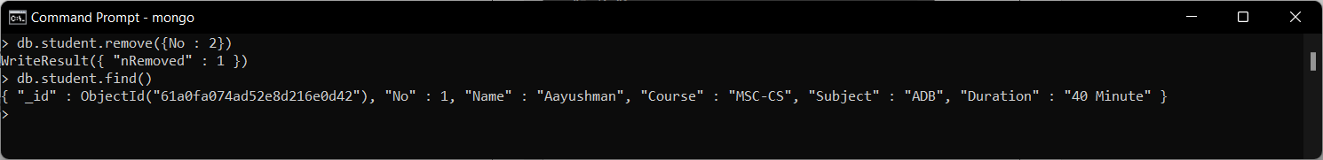

**Conclusion:** Successfully Performed and Implemented the CRUD Operation Using MongoDB.